- Setup one master and two worker nodes in ansible.

Prerequisites :
Infrastructure Requirements
3 Linux servers (Ubuntu 20.04/22.04 recommended)
1 Master Node
2 Worker Nodes
Minimum:
2 CPU
2 GB RAM (4 GB recommended)
20 GB disk
All nodes must:
Have static/private IPs
Be able to communicate with each other
Have internet access

Software Requirements

On Ansible Control Node (your local machine or separate server):
Ansible installed {apt update , apt install ansible}
SSH access to all nodes
Python3 installed

Check:
ansible --version



Create ansible.cfg and hosts (add private ips of worker nodes) at /etc/ansible:

mkdir -p /etc/ansible
vi /etc/ansible/ansible.cfg

[defaults]
remote_user = root
host_key_checking = false
forks = 10

vi /etc/ansible/hosts

[all]
172.31.29.98
172.31.31.21
[worker-1]
172.31.29.98
[worker-2]
172.31.31.21



SSH PASSWORDLESS AUTHENTICATION:

From control node:
Create ssh-keygen , copy the keygen created .

Worker node 1:
Paste the copied key in
/.ssh/authrized_keys

Worker node 2:
Paste the copied key in
/.ssh/authrized_keys

Test:
From control node:
ansible all -m ping
ansible worker-1 -m ping
ansible worker-2 -m ping

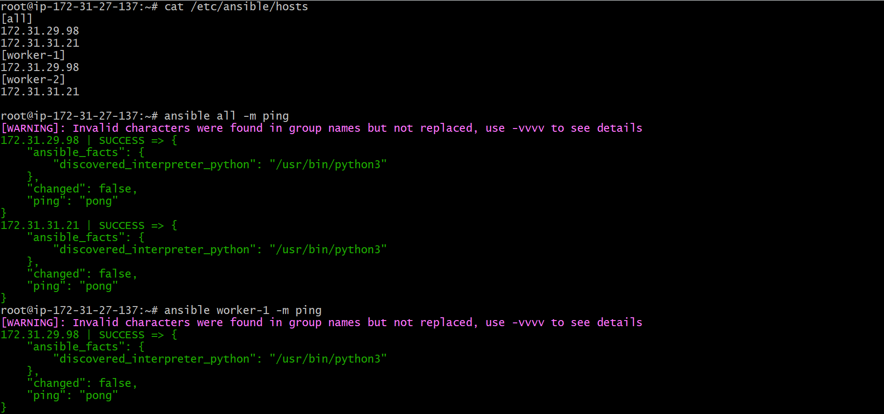


- Execute the adhoc command shared in #dvps-cloud-documents-12 Channel.

- To check the connetivity between slaves
ansible all -m ping
ansible worker-1 -m ping


ansible all -m ping -i ansible_hosts

# Tips: -i is used if we are using more than one invertory file



2) How to gather facts of slave machine
ansible all -m setup



3) What if you do not have SSH key-based? How to pass username and password?
ansible all -m ping --user=ansadm --ask-pass

4) TO checkthe uptime of a slave machine
ansible all -m shell -a uptime

# Tips: -m is the module and -a should contain the command it should run which goes as an argument to command and shell.

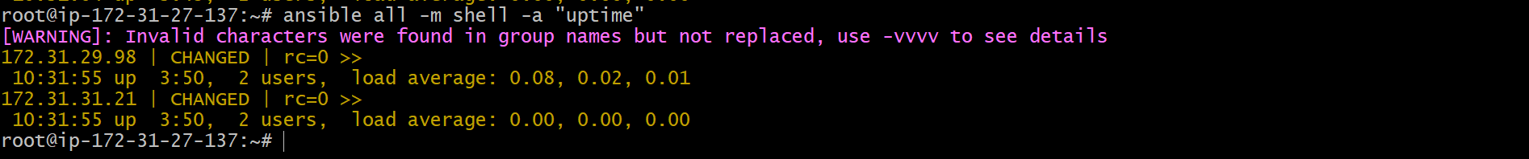

5) check the free memory or memory usage of host
ansible all -a "free -m"

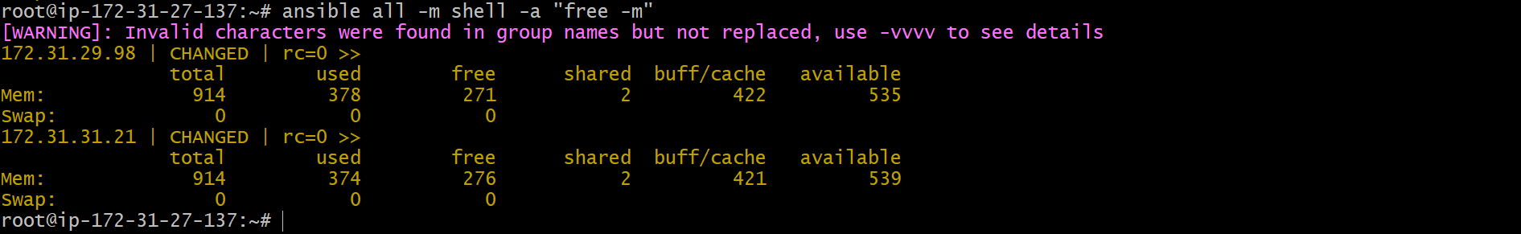

6) Execute a command as root user (sudo) on host
ansible all -m shell -a "cat /etc/passwd|grep -i ansadm" -s --ask-sudo-pass

7) Execute a command using become module
ansible all -m shell -a "cat /etc/passwd|grep -i ansadm" -b -K

# Tips: -b is the option for become and by default it will become root user
–K is to tell ansible to ask for SUDO password

- Execute a command as a different user (sudo su)
ansible all -m file -a "path=/home/ansadm/test state=directory mode=0755" -b --become-user=ansadm

9) Create a Linux user group
ansible all -s -m group -a "name=test state=present" -b -K

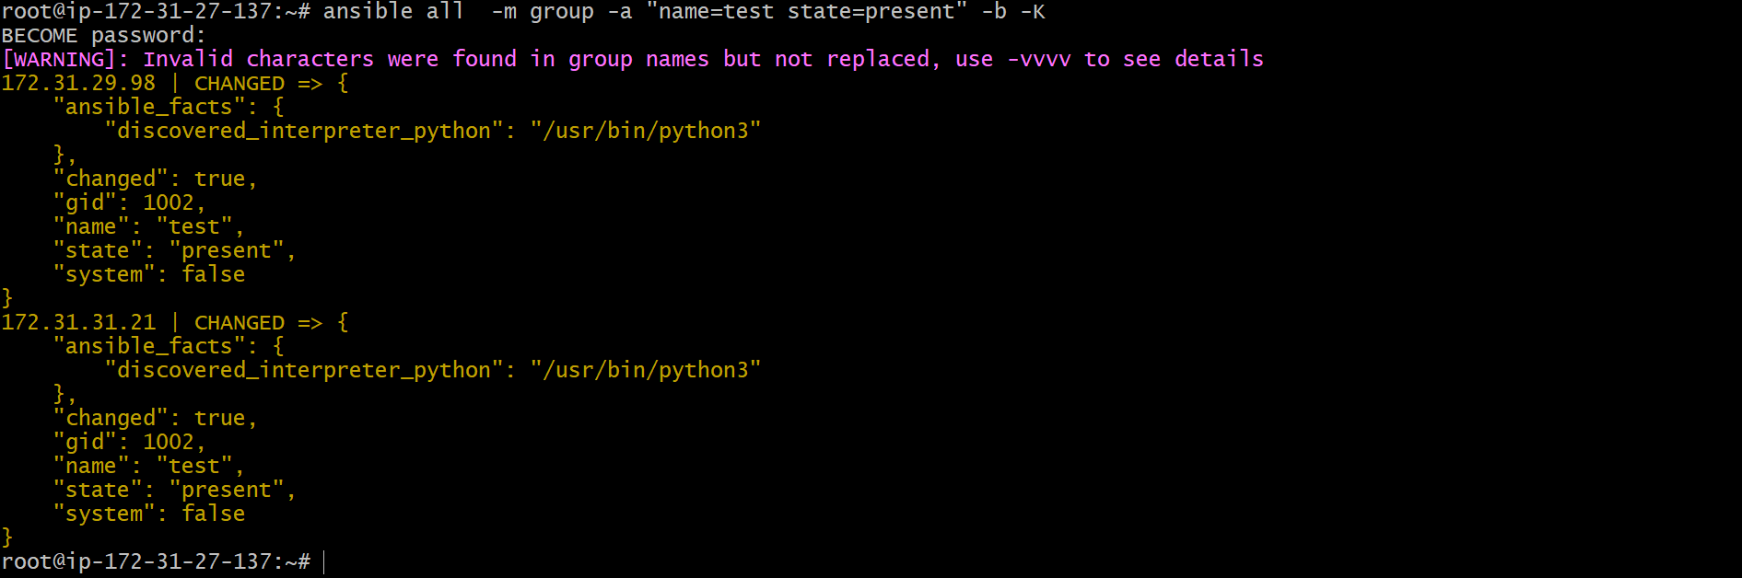

- Create a file with 755 permission

ansible all -b -m file -a "path=/home/ubuntu/world state=touch mode=0755"

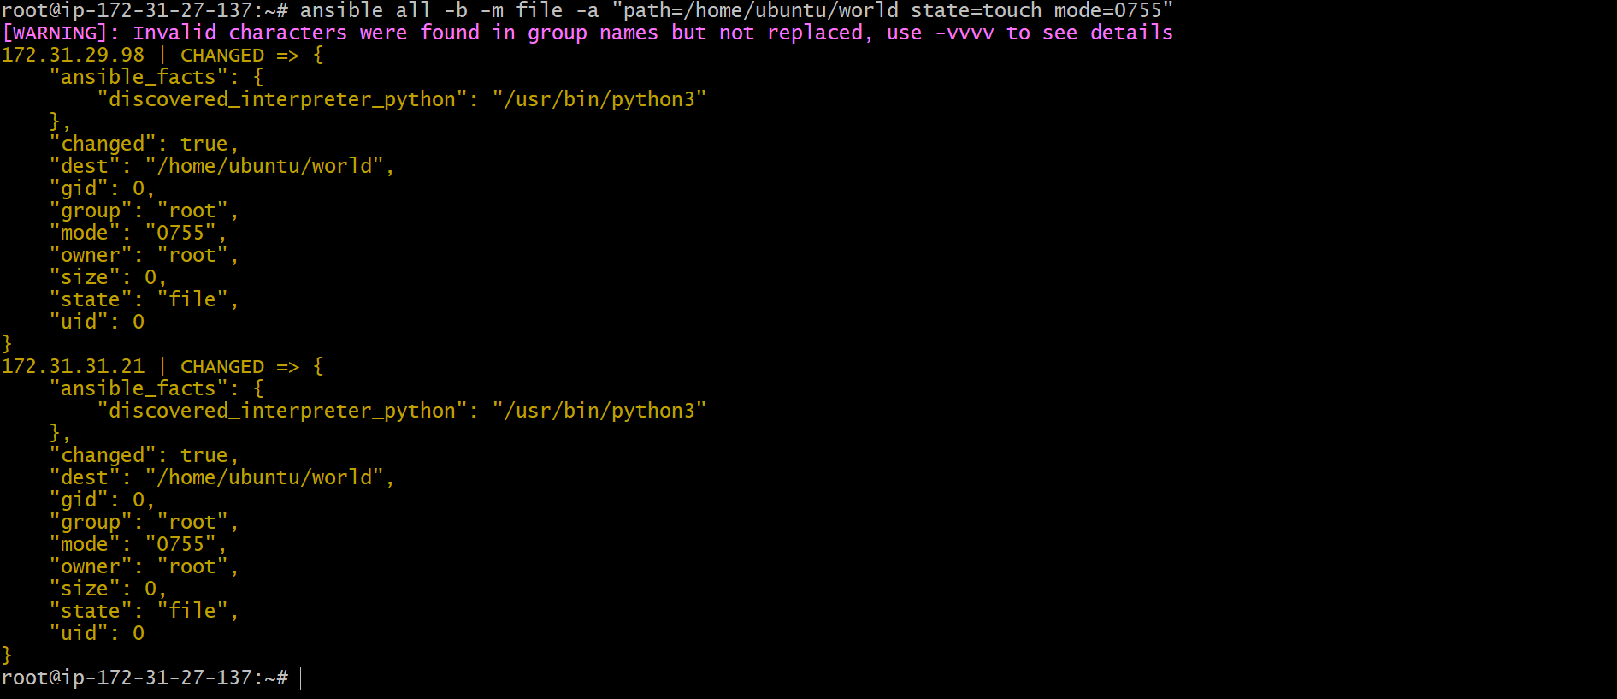

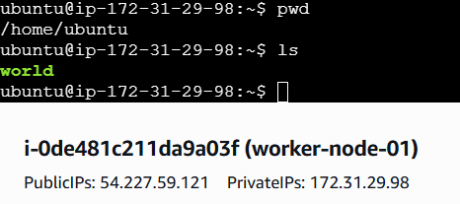

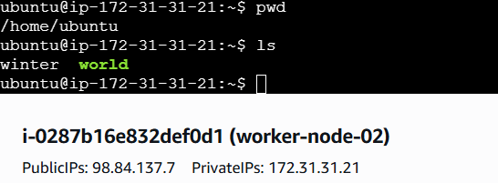

11) Change ownership of a file
ansible all -b -m file -a "path=/home/ubuntu/world owner=aniketh group=aniketh"

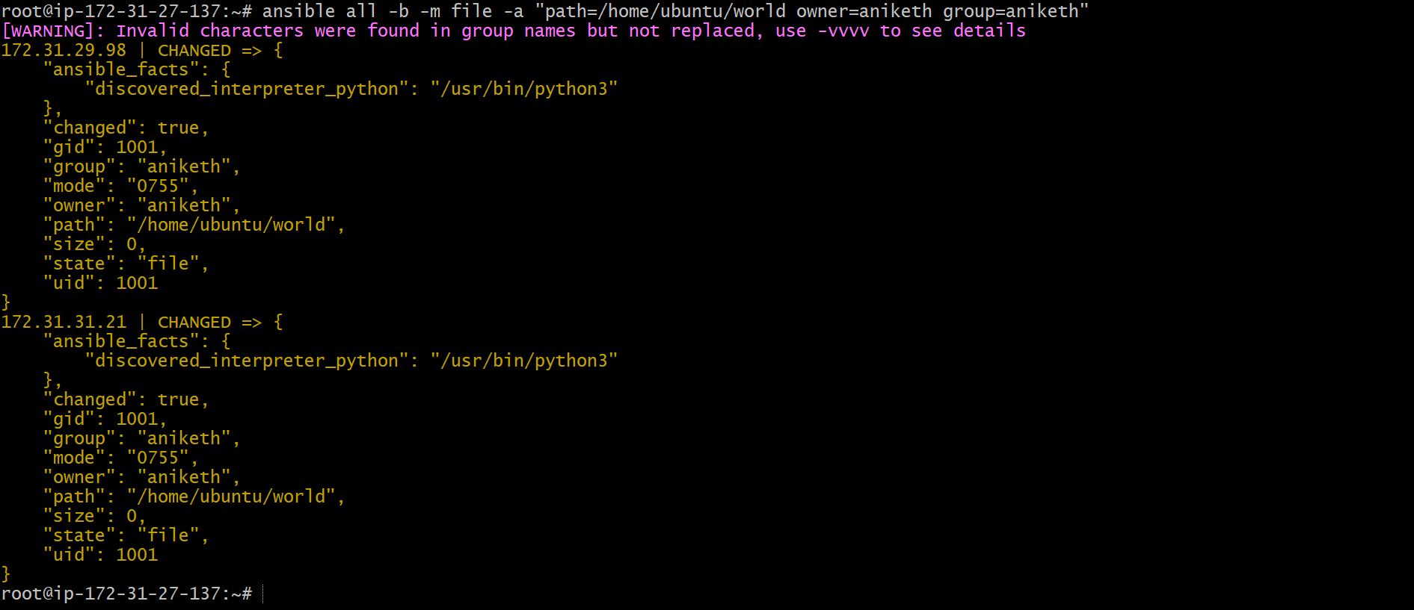
12) Install a package using yum command
ansible all -m yum -a "name=httpd state=installed"

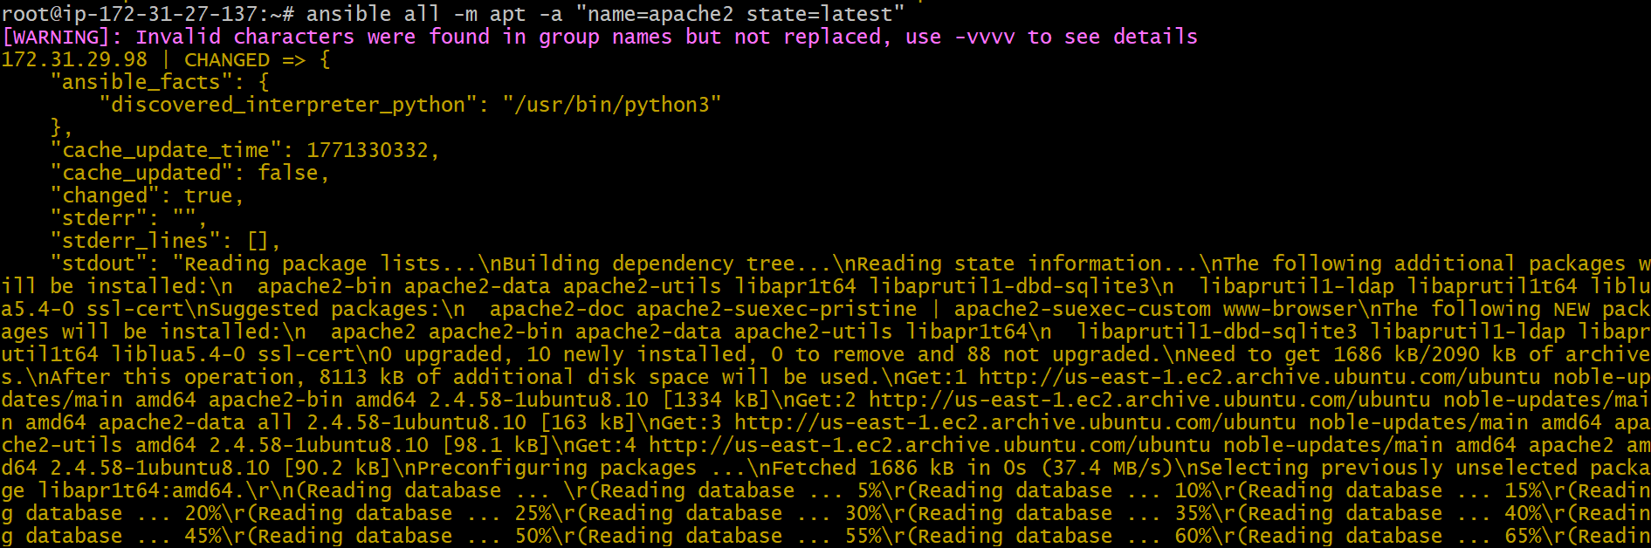

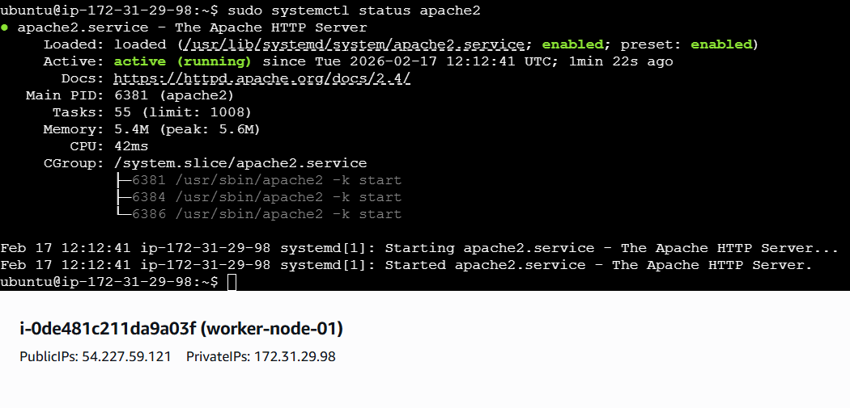
13) Start or stop the service
# To Start
ansible all -m service -a "name=httpd state=started enabled=yes"

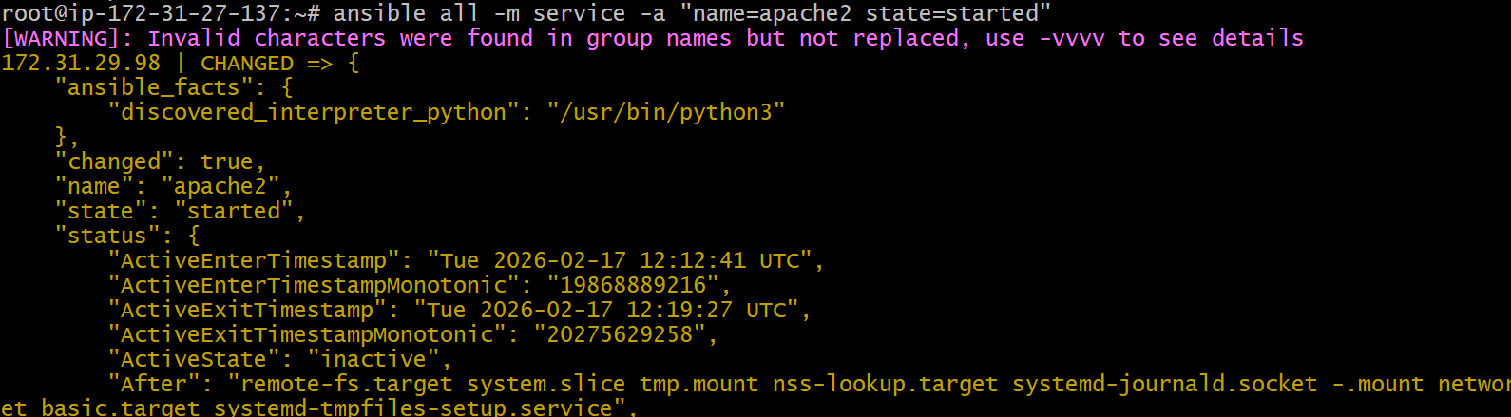

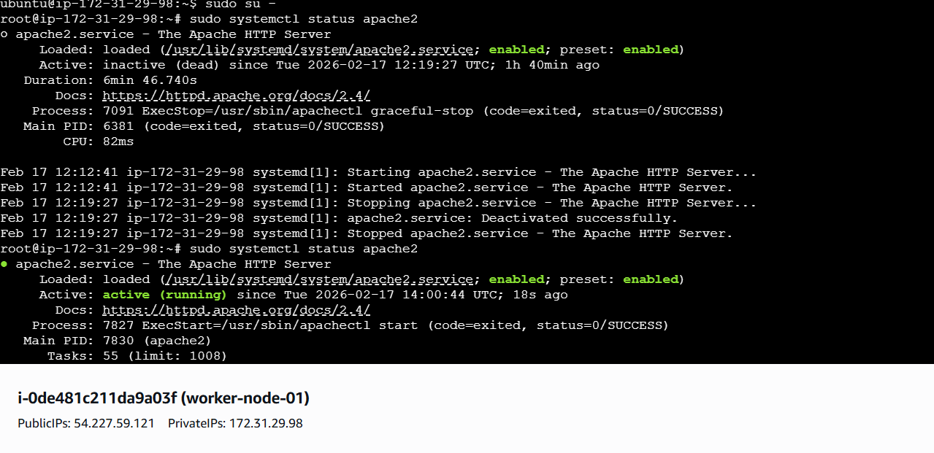

# To Stop
ansible all -m service -a "name=apache2 state=stopped"

